Chapter 18, Problem 37.

Find the transfer function I_{o}(ω)/I_{s}(ω) for the circuit in Fig. 18.39.

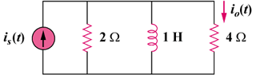

Figure 18.39
For Prob. 18.37.

